**Meeting Minutes**

**Date:** March 9, 2014

**Start Time:** 1:00pm

**End Time:** 4:00pm

**Members Present:** Drew Aaron, Michael Beaver, Chad Farley,

Andrew Hamilton, and Travis Hunt

**Members Absent:** Clay Boren

**Topics** **Discussed**

* Detailed Design
* Coding Standards
* Frontend Development
* Future Meetings

**Decisions and Actions Taken**

Michael, Travis, and Chad continued designing the Backend. They have opted to retain the current overall structure of the main Memory and Register classes. However, Register and Byte will be modified to include a “value” data member. All arithmetical operations will be performed on this “value” member. Also the Register class will have conversion and updater methods. A new abstract base class, Data, will be added. Data will have two methods for converting between Bytes and Strings. These conversion methods will be used to facilitate the actual arithmetical operations. See the attached class hierarchies and example pseudocode.

The team will work on developing all pseudocode and the information flow diagram at the next meeting. This work should be concluded by March 20, 2014.

Andrew continued working on the coding standards. A finalized version should be ready by the next team meeting.

Drew began working on developing the frontend user interface. Currently the frontend is a near replica of the Prototype. Drew and Clay will need to create a customized textbox with line numbers and column numbers. The functional first phase of the Frontend will be completed by March 20, 2014. This version of the Frontend will have all basic functionality, basic syntax highlighting, and the custom textbox.

The team has also scheduled the three next team meetings. See the attached schedule. The next team meeting will be Tuesday, March 11, 2014 at 3:30pm in the Commons building.

**Supplementary Information**

**Data Class**

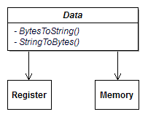

**Updated Register Hierarchy**

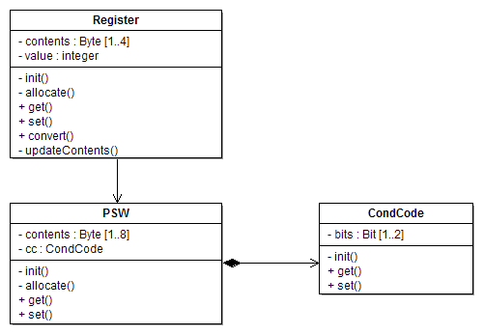

**Updated Memory Hierarchy**

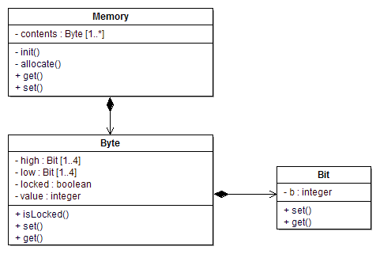

**Add Register (AR) Pseudocode**

AR R1,R2

val1 := Convert.ToInt32(R1.BytesToString(R1.GetContents()), 16)

val2 := Convert.ToInt32(R2.BytesToString(R2.GetContents()), 16)

val1 := val1 + val2

result := val1.ToString(“X”)

result := result.PadLeft(result, ‘0’)

R1.UpdateContents(StringToBytes(result))

**Upcoming Meetings**

* Tuesday, March 11, 2014
  + 3:30pm
  + Commons Building
* Thursday, March 13, 2014
  + 3:30pm
  + Commons Building
* Friday, March 14, 2014
  + 6:00pm
  + Christian Student Center